|  |
| --- |
| Report on Power Bi |
| A Statistical Analysis Tool |

|  |
| --- |
| 38 | By: Akshat Kakkad |



|  |
| --- |
| Analysis of Olympics’ Athletes |
| Using Power Bi |
| Reason for Selection. Power Bi is the easiest tool to start Statistical analysis digitally. We just need to load the data in tool and then perform different operations on it and can visualize many of the charts and Graphs based on our data. Power Bi desktop version for a new learner is available free of cost in Microsoft store, and we just need to download it and play with the tool.  Logo of Power Bi. Loading Data We can easily load any type of data in Power Bi for simulation. We just need to click the Get Data button and we will be asked which type of data you want to load and analyze (Excel, SQL, Power Bi Datasets, etc.) So we can choose the desired one and then move forward to editing (if any) or directly start different Visualizations.    duvs Viusalization On the Insert tab, the galleries include items that are designed to coordinate with the overall look of your document. You can use these galleries to insert tables, headers, footers, lists, cover pages, and other document building blocks. When you create pictures, charts, or diagrams, they also coordinate with your current document look.  You can easily change the formatting of selected text in the document text by choosing a look for the selected text from the Quick Styles gallery on the Home tab. You can also format text directly by using the other controls on the Home tab. Most controls offer a choice of using the look from the current theme or using a format that you specify directly.  To change the overall look of your document, choose new Theme elements on the Page Layout tab. To change the looks available in the Quick Style gallery, use the Change Current Quick Style Set command. Both the Themes gallery and the Quick Styles gallery provide reset commands so that you can always restore the look of your document to the original contained in your current template. |

## Editing and Cleaning

After Loading the data in our Power Bi, we can edit and clean it. For Example, if we do not want some rows or some columns, we can cancel them out. We also can add any if needed. We can also delete some cells from our data and many more operations can be done here. We can perform editing by clicking on Transform data button.



## Visualization

After Loading our data, we can try out charts and graphs for the analysis. There are many different types of visuals offered by Power Bi like line chart, bar plot, pie chart, Donut Chart, Scatter plot, Tree map, Global Map and many more. We can implement them just by clicking on the icon and the drag and drop the fields required by Visual.

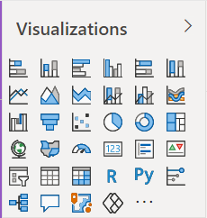

## Analytics

After creating any chart or Graph if we want to perform analysis on it then we have a button just below the visualization. We can add some lines to our data and see and analyze it at our end as well as keep them in result also.



## Format

We can also perform formatting on the visuals we created such as text size, text color, background, title, names of X and Y axis etc. Format button is also just below visualization in Power Bi.



## Fields

When we want to create any visual for our data, we need to specify our fields in the fields section. We need to tell our tool that what we need as our parameter, or what we need on the two axis of graph to analyze in our graph. Field button is also just below visualization in Power Bi.



## Filters

Suppose we are analyzing very large data, we cannot perform our analysis at once or just having one graph which has all the values, so sometimes we need to perform analysis on a particular segment of data, and this can be done using filters. There are three types of filters available basic, advanced, and top. (All types are explained in video). Filter portion is available on left of visualization in Power Bi.

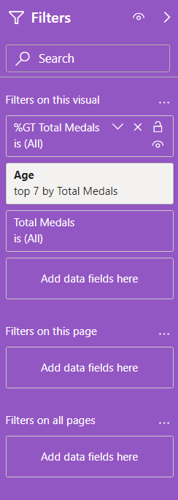

## Designing (UI)

To make our report interesting and to provide some good visual effect to the reader we have designing functions in our tool. We can Insert images, text boxes, comments, navigation buttons etc. We use insert button in the top pane to do this. Along with this we also have many other designing options like background design (Theme). We can also Design our report in Mobile View.

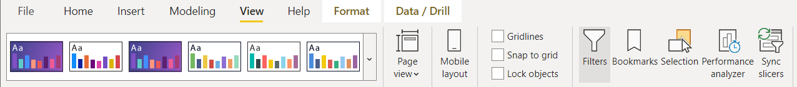

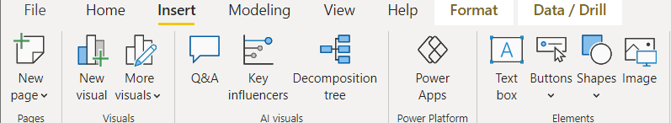

## Live Database (Refresh Button)

The best thing in Power Bi and the most important feature of it is live data base. Suppose we have continuously changing data, and we want to analyze that, then we just need to click the refresh button in our home pane and all modified data in our data base will be loaded in Power Bi, and it will also change all the graphs and charts we implemented automatically. So, to analyze frequently changing data we can use this tool as charts and Graphs already implemented will also modify if needed directly.

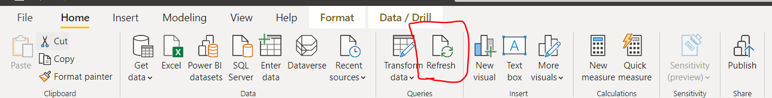

## Available & New Measures defining

There are many predefined measures available in Power Bi to assign them in fields. We have measures like sum, variance, Standard deviation, mean, median and mode etc. Which we can assign to any integer or float column of our data and directly get answer based on values present in column. We can also define our new measure base on need.

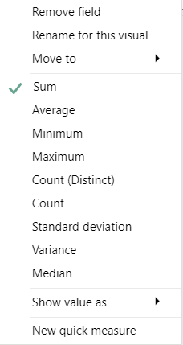

## Question Answers

This is also one of the important features of Power Bi. This feature is based on AI in Power Bi. If we are having any question in our mind related to data, then we can directly fire it by clicking on Question-and-answer button. If possible, it gives us the solution with best possible chart or graph or it just gives the calculated value.

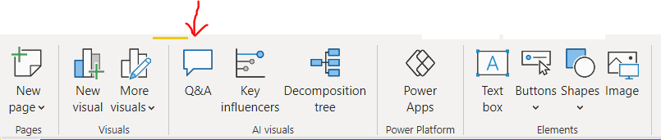

## Conclusion

Power Bi is very Powerful and most popular tool used professionally for data analysis. Data up to 100’s of millions of length is supported by this tool. It has numerous features out of which some are listed above. We can draw any chart or graph by just drag and drop of fields from our database and also, we can define our new measures if needed to analyze our data. It is also able to analyze frequently changing data with the help of refresh button. Charts and graphs are modified according to new modified data after pressing refresh button. It also gives suggestions that which visual will be best suited for analysis of any task.

# Screenshots: -

